**1. Project Title and details**

Project Title: Urban Luxe – Fashion Lookbook Website

Team Members:

Steeva Mariam Jose – Roll No: 2462186 – Email: steevamariam@btech.christuniversity.in

Stuti Aradhana Prusty – Roll No: 2462158 – Email: stuti.aradhana@btech.christuniversity.in

T Lakshmi Swetha – Roll No: 2462164 – Email: turimella.lakshmi@btech.christuniversity.in

**2. Abstract**

Urban Luxe is a modern, luxury-themed fashion lookbook website designed to showcase standout seasonal collections in an editorial, interactive, and mobile-responsive format. This project leverages HTML5 and advanced CSS3 for a fully dark-themed, visually striking layout, aligning with the aesthetics of high-end brands like Akris. Core features include a striking hero section, interactive image gallery with look subtitles, a trends spotlight, awards, customer reviews, press mentions, newsletter signup, and rich contact options. Designed for an elegant and seamless experience, Urban Luxe demonstrates mastery in CSS Grid, Flexbox, and image presentation, without the need for JavaScript. This report covers the technical structure, design decisions, brand-focused stylistic choices, challenges encountered, solutions implemented, and recommendations for future enhancements.

**3. Objectives**

* Create a visually immersive, high-impact digital fashion lookbook that reflects luxury minimalism.
* Ensure mobile responsiveness and optimal image presentation using CSS Grid and Flexbox.
* Incorporate engaging sections such as testimonials, awards, press mentions, and social links to build brand credibility and interaction.
* Implement all interactivity and effects using only HTML5 and CSS3, without JavaScript.

**4. Scope**

The website presents a curated showcase of seasonal looks, customer sentiment, and accolades, all within a single-page, dark-themed digital experience suitable for desktop and mobile devices. The lookbook is intended for brand marketing, style inspiration, and user engagement, demonstrating effective use of core web technologies.

**5. Tools & Technologies**

* HTML5, CSS3 (including CSS Grid & Flexbox)
* Visual Studio Code
* Google Fonts (Montserrat, Playfair Display)
* GitHub (for version control)
* Unsplash/Pexels/SVGs for demo images and logos

**6. HTML Structure Overview**

* Hero Section – Large statement image and tagline
* Collection Gallery – Grid of images with captions
* Trend Spotlight – Featured trend cards
* Press Mentions – Brand logos in a horizontal row
* Customer Reviews – Testimonial cards in grid
* Store Locator – Boutique details
* Contact – Email & social profiles
* Newsletter Signup – Email capture form

**7. CSS Strategy**

* Layout: Responsive CSS Grid for galleries, Flexbox for cards, press logos, and awards
* Typography: Editorial headings with Playfair Display, body text with Montserrat
* Color Scheme: Fully dark theme (near-black backgrounds, warm orange accent, soft greys)
* Effects: Hover overlays, transitions for captions/logos, box shadows for depth
* Media Queries: For 2-column, single-column layouts on tablets/mobiles
* SVG Support: Ensures logos remain sharp and scalable

**8. Key Features**

* Visually immersive dark hero section with branded tagline
* Responsive image gallery with bottom overlay captions
* Trend Spotlight cards with color accents
* Testimonials from real and demo clients in grid
* Newsletter signup form (CSS-only)
* Clickable contact links (email, Instagram, Twitter)

**9. Challenges & Solutions**

* Image brightness on dark backgrounds: Applied CSS filters for visibility and consistency without washing out contrast.
* Maintaining crisp brand logos: Used SVG files for logos with flex and gap for perfect, scalable spacing.
* No JavaScript for interactivity: Used only visual cues (tabs, form) and CSS :hover for feedback; form is purely demo/static.
* Ensuring readability: Used high-contrast text and subtle overlays to maintain editorial readability.

**10. Outcome**

Urban Luxe provides an upscale, interactive lookbook platform that is engaging, mobile-optimized, and visually consistent with high-fashion branding—all with pure HTML and CSS.

**11. Future Enhancements**

* Implement functional filtering (with JavaScript) for dynamic look browsing.
* Add a back-office CMS or markdown-based system for collection updates.
* Integrate an Instagram live feed for real-time brand content.
* Improve newsletter signup with proper backend integration.
* Add light/dark theme toggle for user preference.

**12. Screenshots**

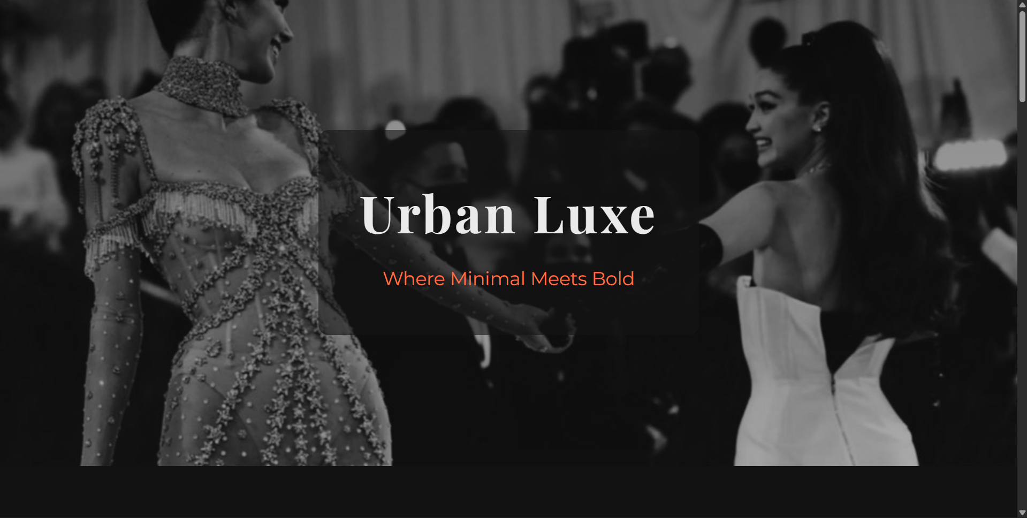

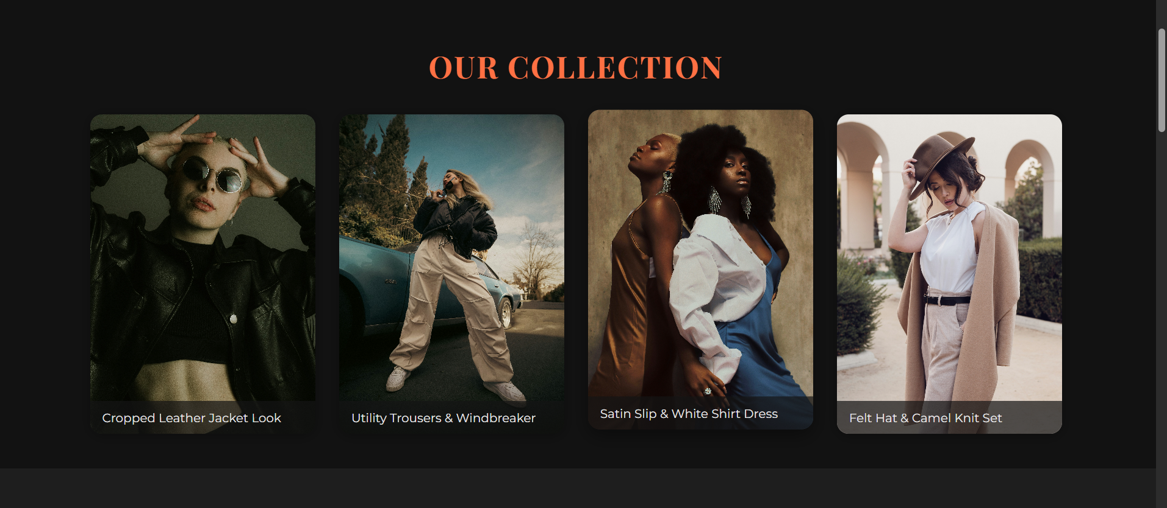

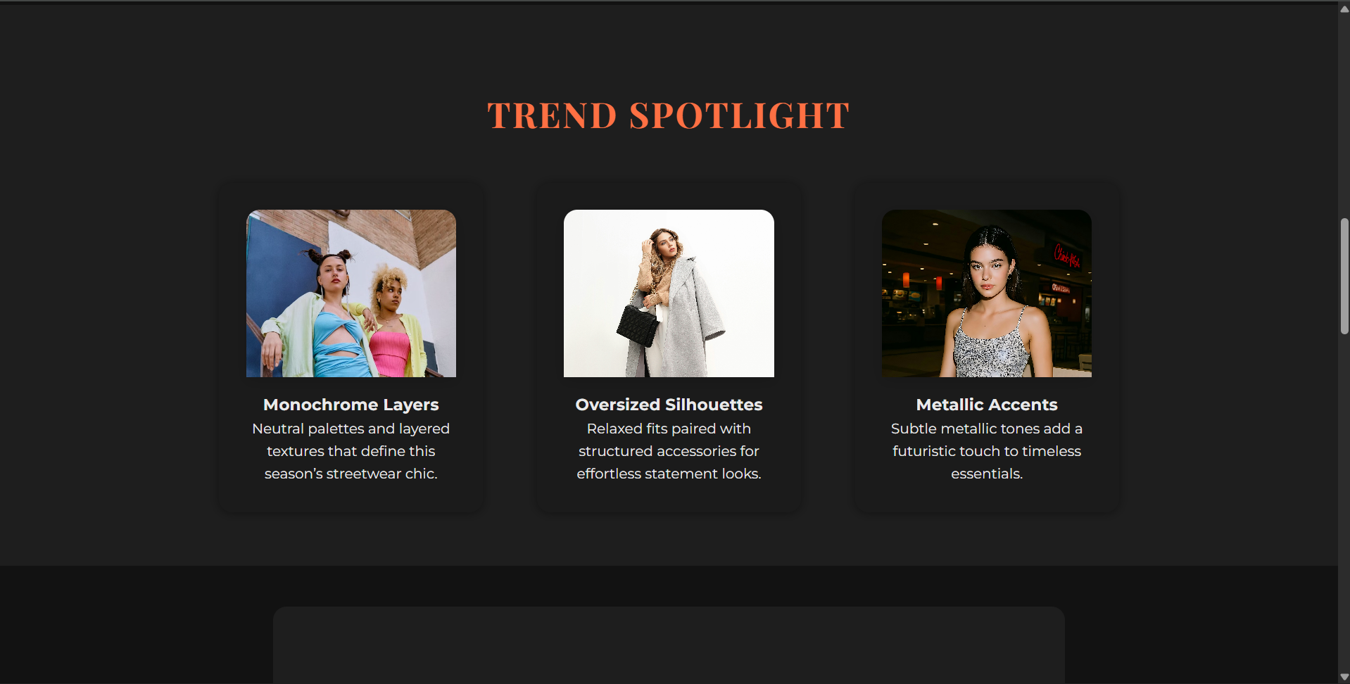

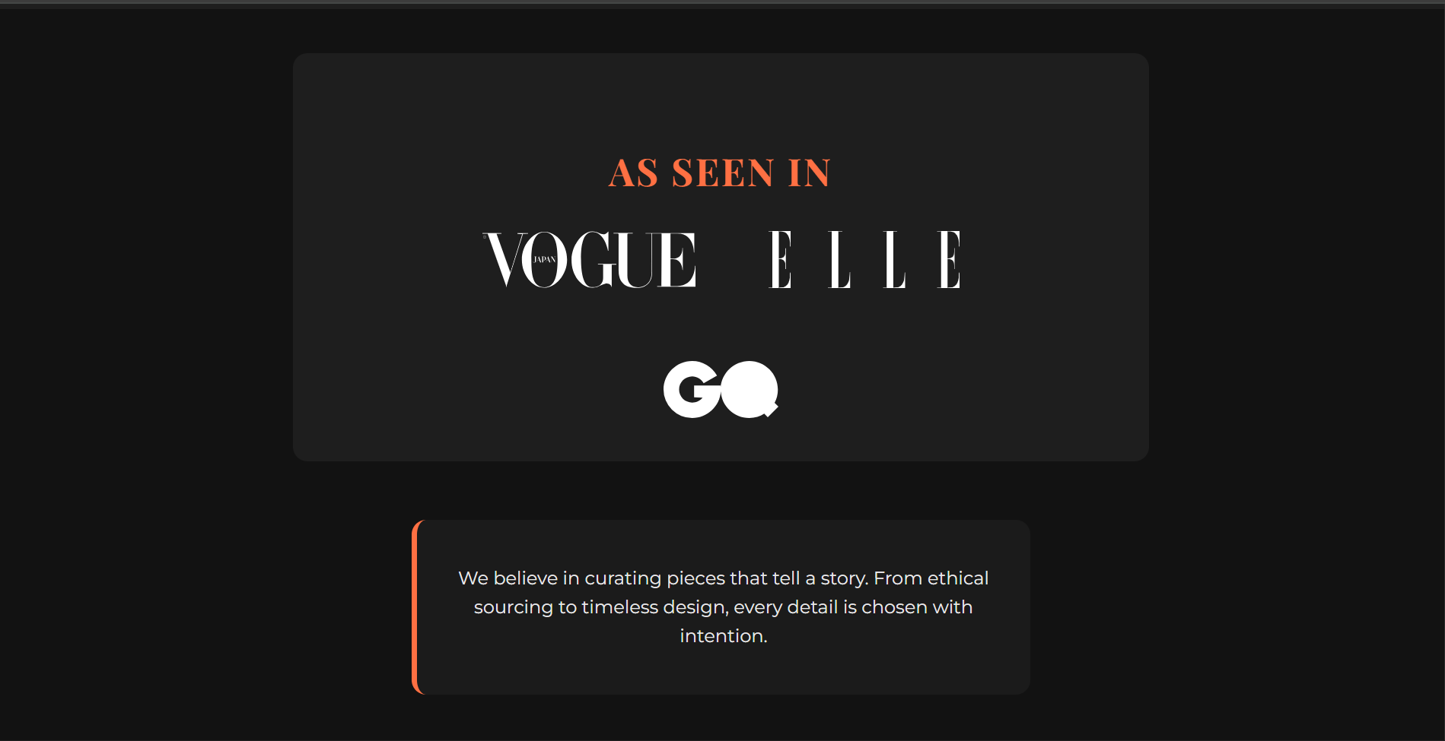

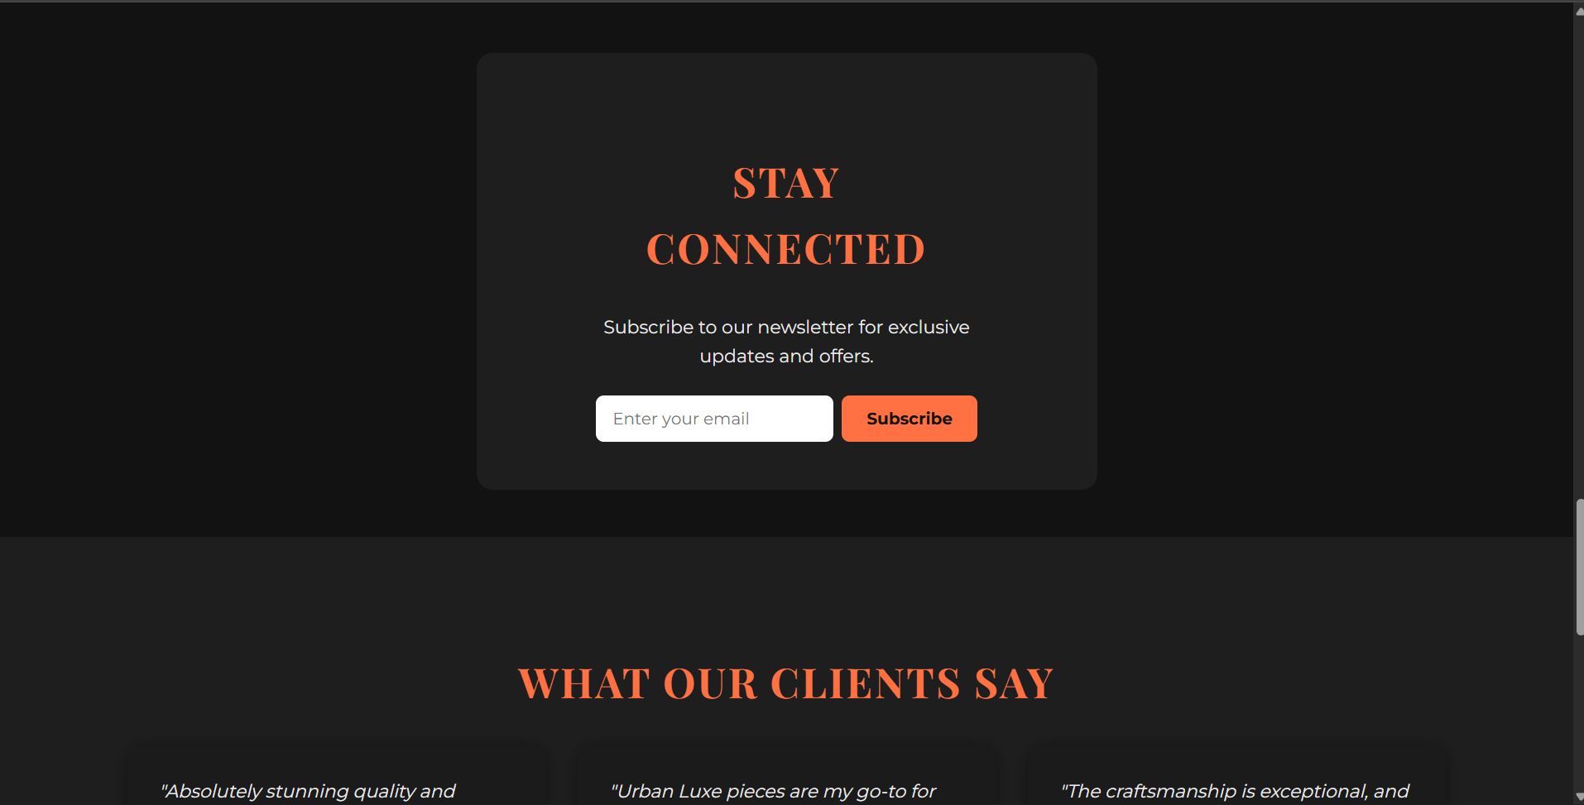

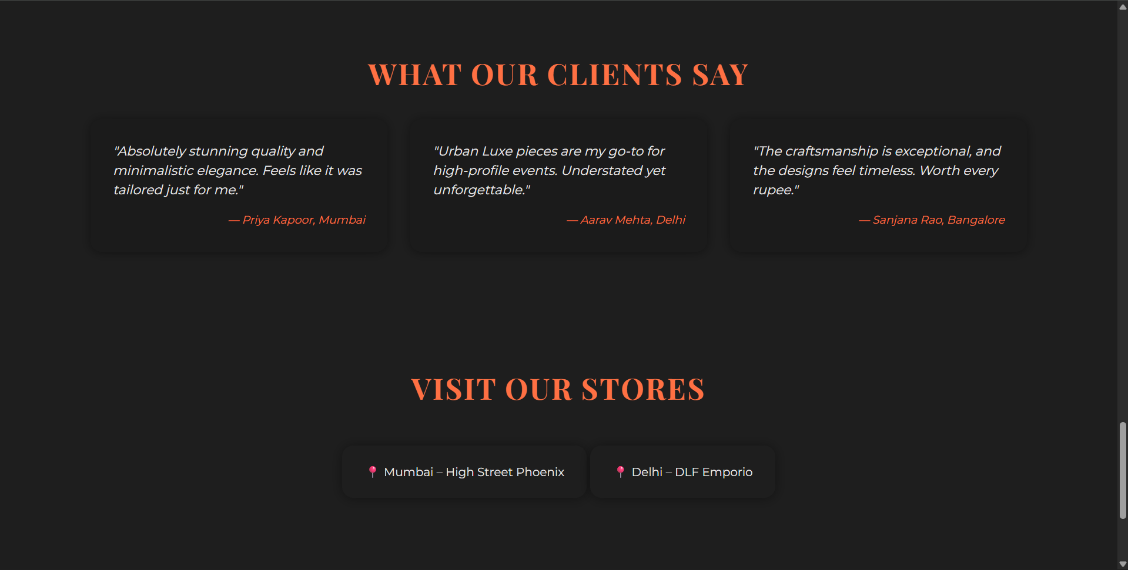

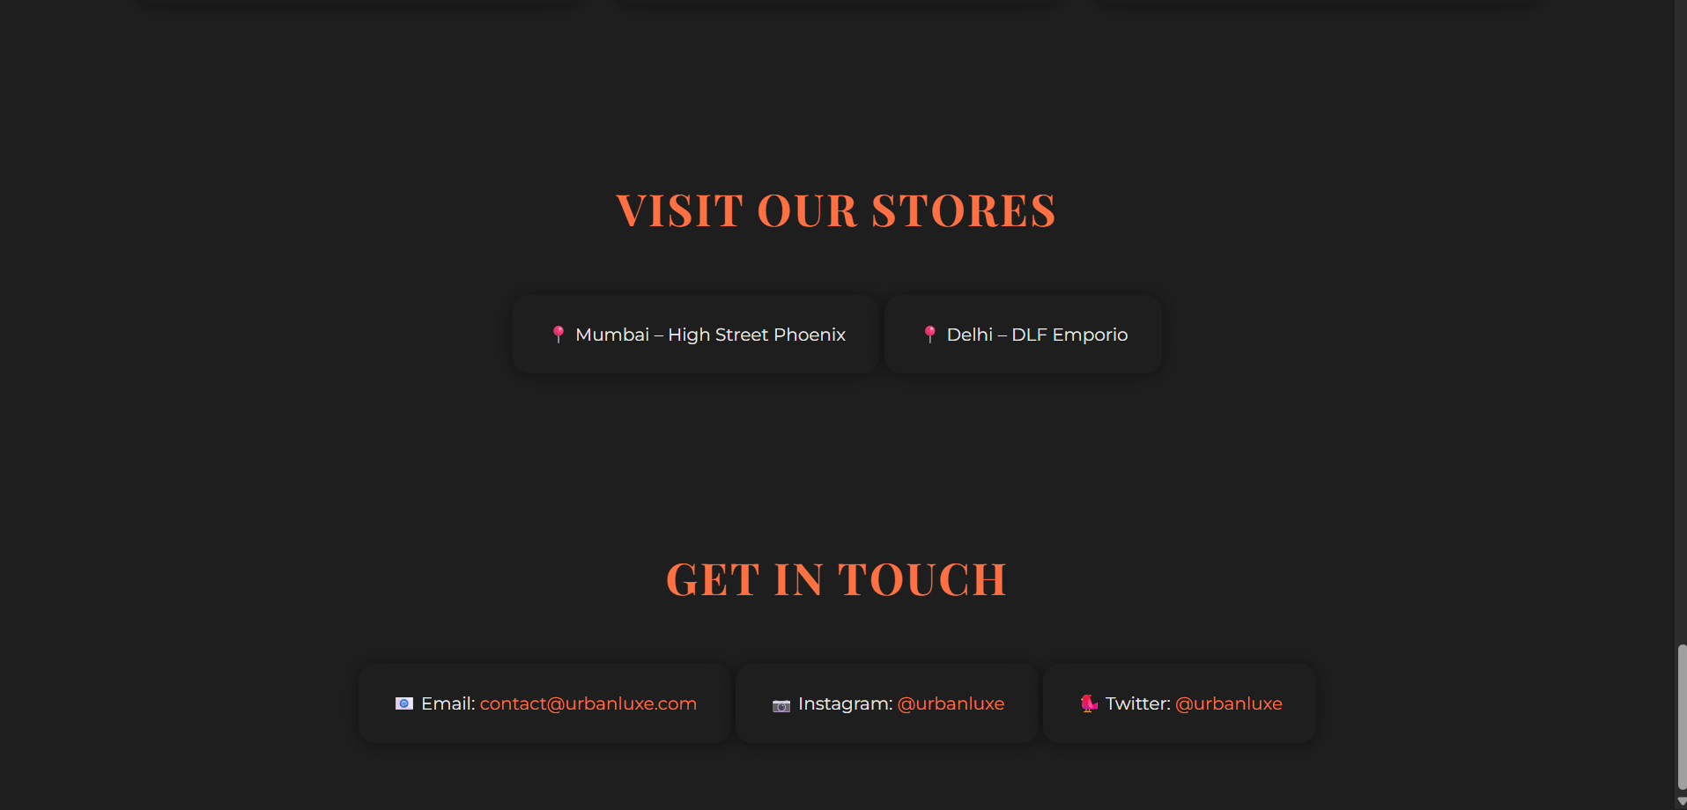

**14. Conclusion**

This project demonstrates the power of modern CSS and semantic HTML in creating rich, interactive, and brand-accurate digital experiences for fashion. The website’s luxury visual narrative, editorial typography, and seamless mobile adaptation make it suitable for any high-end brand seeking a sharp digital presence.

**15. References**

* [w3schools.com](https://w3schools.com/)
* [MDN Web Docs](https://developer.mozilla.org/)
* [Unsplash – Free Fashion Photos](https://unsplash.com/)
* [Pexels – Fashion Photos](https://pexels.com/)
* [Google Fonts – Montserrat, Playfair Display](https://fonts.google.com/)
* [SVG Logos – Brands](https://seeklogo.com/)